Expt No:  04 | MATERIAL HANDLING SYSTEM
Date:
/ /2025

- AIM:
To develop a ladder logic program for the material handling system.
- APPARATUS REQUIRED:

- Material Handling system.
- PLC Trainer Kit.
- Personal Computer [PC].
- VersaPro Software Installed.
- RS - 232 cable.
- Patch Chords.

- PROCEDURE:

- Load the Versapro Software to the PC.
- Open the Versapro Software.
- Switch ON the PLC Trainer and Material handling System.
- Connect PLC and Material handling System kit.
- Open the New folder and draw the ladder logic program.
- Connect the PLC to PC.
- Select the correct hardware Configuration [Sl. No].
- Store the Program to PLC.
- Run the Program.
- Verify the performance of the Material handling System.

- PROBLEM STATEMENT:

In the material handling system, the arm first moves to the initial position, which is defined by the limit switch (i1). Once the arm is in this position, the program starts running, and the conveyor system is activated. The conveyor stops when the sensor (i3) detects a high signal. After this, the arm rotates from the initial position (i1) to position (i2). When the input signal (i2) is high, the output coil is energized, causing the electromagnet to activate. The electromagnet grabs the material and the arm rotates in the reverse direction.

As the arm moves, it will eventually reach the (i1) limit switch again. When the (i1) switch is triggered, the input (i1) goes high, which de-energizes the coil (the output coil is turned off). This causes the electromagnet to release the material, dropping it into the storage box.

The material handling system consists of the following interfaced to a micro-PLC:
- Stepper motor 1- To rotate a container belt,
- Stepper motor 2- To move a arm,
- Electromagnet - To pick a material (It is mount in arm end),
- Limit switches (LS1, LS2) - To Control the arm position.

- WIRING DIAGRAM:

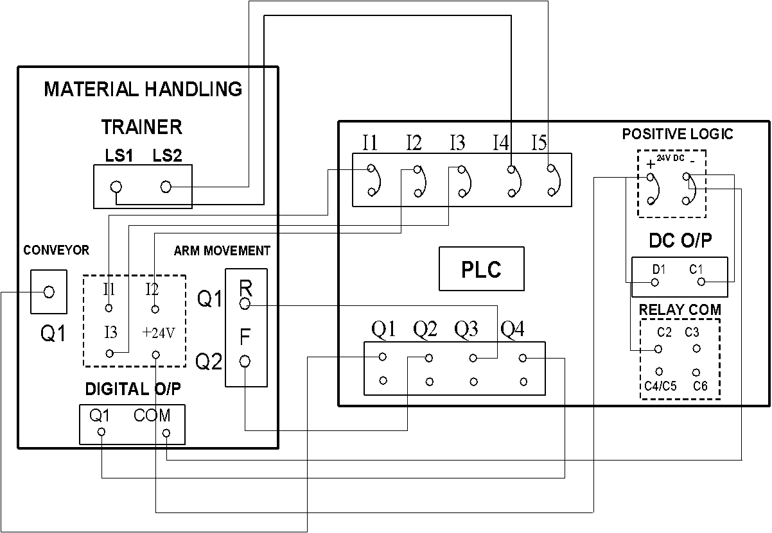

- LADDER DIAGRAM:

- INPUT USED:

- Start Button: A normally open pushbutton to begin the machine cycle.
- Stop Button: A normally closed pushbutton to halt the machine cycle.
- Limit Switch 1 (i1): A sensor that is activated when the robotic arm is at its home/initial position (the drop-off point).
- Limit Switch 2 (i2): A sensor that is activated when the robotic arm is at the material pickup position.
- Material Sensor (i3): An optical or proximity sensor that detects when a material part is in position on the conveyor belt.

- OUTPUT USED:

- Conveyor Motor: A motor (Stepper Motor 1) that drives the conveyor belt forward.
- Arm Motor Forward: A motor (Stepper Motor 2) that rotates the arm from the home position (i1) to the pickup position (i2).
- Arm Motor Reverse: A motor (Stepper Motor 2) that rotates the arm from the pickup position (i2) back to the home position (i1).
- Electromagnet: A coil that, when energized, picks up and holds the metallic material.

- I/O MAPPING:

Device Name | Description | Versapro PLC Address
--- INPUTS ---
Start Button | Starts the automatic cycle | %I00001
Stop Button | Stops the automatic cycle | %I00002
Limit Switch 1 (i1) | Detects arm at home/drop position | %I00003
Limit Switch 2 (i2) | Detects arm at pickup position | %I00004
Material Sensor (i3) | Detects material on conveyor | %I00005
--- OUTPUTS ---
Conveyor Motor | Runs the conveyor belt | %Q00001
Arm Motor Forward | Rotates arm from i1 to i2 | %Q00002
Arm Motor Reverse | Rotates arm from i2 to i1 | %Q00003
Electromagnet | Energizes to pick up material | %Q00004

- RESULT:
Thus, the ladder logic program for the material handling system is developed and tested using hardware kit.

